Question 1)

public class q1 {  
 public static void main(String[] args) {  
 int[] Num = {40,28,10,81,23,45,47,18,76,64};  
 for(int i : Num){  
 System.*out*.println(i);  
 }  
 }  
}

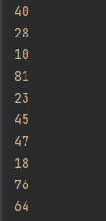

Question 2)

public class q2 {  
 public static double *total*;  
 public static double *avg*;  
 public static int *p*=0;  
 public static void main(String[] args) {  
 double[][] weights = {{54.5, 50, 48}, {43, 56.5, 67, 65.5, 59}, {45, 55, 63, 45.5, 54.5},  
 {66, 49.5, 56}};  
  
 for(double[] x:weights){  
 *p*++;  
 for(double y: x){  
 *total* = *total* +y;  
 }  
 System.*out*.printf("Group %d Average Weight: %.2f\n",*p*,(*total*/x.length));  
 *total*=0;  
 }  
 }  
 }

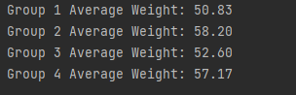

Question 3)

public class q3{  
 public static int *i*,*y* =1;  
 public static void main(String[] args) {  
  
 String[][] students ={{"heshan","abhishekya","kasun"},{"pasan","dilhara","Yoosuf"},{"ayodya","naveen","kanishka"}};  
  
 System.*out*.println("Seat No Student");  
 System.*out*.println("-------------------");  
  
 for (String[] name:students){  
 *i*++;  
 for (String p:name){  
 System.*out*.println(*i*+""+*y*+" "+p);  
 *y*++;  
 }  
 *y*=1;  
 }  
 }  
 }

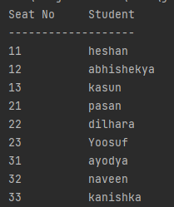

Question 4)

import java.util.Scanner;  
public class q4{  
 public static void main(String[] args) {  
  
 Scanner input =new Scanner(System.*in*);  
  
 System.*out*.print("Enter Date like this (december 8, 2024):");  
 String date = input.nextLine();  
/\*  
 StringBuilder sb = new StringBuilder(date);  
 sb.deleteCharAt(0);  
 sb.deleteCharAt(sb.length()-1);  
 System.out.println(sb.toString());  
\*/  
 date=date.trim();  
 System.*out*.println(date);  
 System.*out*.println(date.indexOf(" "));  
 System.*out*.println(date.indexOf(","));  
 String[] newarr = date.split(" ");  
 System.*out*.println("Month: "+newarr[0]);  
 System.*out*.println("date: "+newarr[1].replace(",",""));  
 System.*out*.println("Year: "+newarr[2]);  
 char first = Character.*toUpperCase*(date.charAt(0));  
 String others = date.substring(1,8);  
 System.*out*.println(first);  
 System.*out*.println(others);  
  
  
  
  
  
  
  
 }  
}

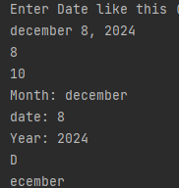

Question 5)

import java.util.Scanner;  
import java.util.Arrays;  
public class q5{  
  
 public static void main(String[] args) {  
  
 Scanner input = new Scanner(System.*in*);  
 System.*out*.print("Enter first String:");  
 String name1 = input.nextLine();  
 System.*out*.print("Enter second String:");  
 String name2 = input.nextLine();  
  
 String[] arr = {name1,name2};  
 Arrays.*sort*(arr);  
 System.*out*.println("Ordered Strings: "+arr[0]+", "+arr[1]);  
 }  
 }



Question 6)

import java.util.Scanner;  
import java.util.Arrays;  
public class q6{  
  
 public static void main(String[] args) {  
  
 Scanner input = new Scanner(System.*in*);  
 System.*out*.print("Enter Name:");String name = input.nextLine();  
 System.*out*.print("Enter Age:");String age = input.nextLine();  
 System.*out*.print("Enter Gender");String gender = input.nextLine();  
 System.*out*.print("Enter weight(kg)");String w = input.nextLine();  
 System.*out*.print("Enter height(m)");String h = input.nextLine();  
  
 Double weight = Double.*parseDouble*(w);  
 Double height = Double.*parseDouble*(h);  
  
 double BMI = weight/(height\*height);  
 String BMItype;  
  
 if(BMI>=30){  
 BMItype ="Obesity";  
 } else if (BMI>=25) {  
 BMItype ="Overweight";  
 } else if (BMI>=18.5) {  
 BMItype ="Normal weight";  
 } else {  
 BMItype ="Underweight";  
 }  
 System.*out*.println("Hi "+name+"!");  
 System.*out*.println("Here are your details:");  
 System.*out*.println("Age: "+age);  
 System.*out*.println("Gender: "+gender);  
 System.*out*.println("Weight: "+weight+" kg");  
 System.*out*.println("Height: "+height+" m");  
 System.*out*.printf("BMI: %.2f\n",BMI);  
 System.*out*.println("Category: "+BMItype);  
   
 }  
 }

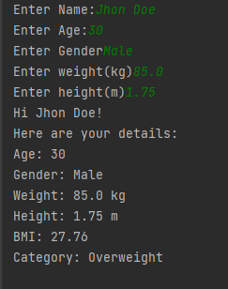

Question 7)

import java.util.Scanner;  
public class q7 {  
  
 public static void main(String[] args) {  
 Scanner input = new Scanner(System.*in*);  
  
 System.*out*.print("Enter a Character: ");  
 char letter = input.next().charAt(0);  
  
 if (Character.*isLowerCase*(letter)) {  
 char letter1= Character.*toUpperCase*(letter);  
 System.*out*.println("You entered a lowercase letter "+letter+".Converted to uppercase: "+letter1);  
 }else if(Character.*isUpperCase*(letter)){  
 char letter1= Character.*toLowerCase*(letter);  
 System.*out*.println("You entered a uppercase letter "+letter+".Converted to lowercase: "+letter1);  
 }else{  
 char letter1= Character.*toLowerCase*(letter);  
 System.*out*.println("You entered "+letter+". which is not an alphabet.");  
 }  
 }  
}







Question 8)

import java.util.Scanner;  
public class q8{  
  
 public static void main(String[] args) {  
 Scanner input = new Scanner(System.*in*);  
 System.*out*.print("Enter Day Value: ");  
 int value = input.nextInt();  
  
 switch (value){  
 case 1:  
 System.*out*.println(value+" is Monday ");  
 break;  
 case 2:  
 System.*out*.println(value+" is Tuesday ");  
 break;  
 case 3:  
 System.*out*.println(value+" is Wednesday ");  
 break;  
 case 4:  
 System.*out*.println(value+" is Thursday ");  
 break;  
 case 5:  
 System.*out*.println(value+" is Friday ");  
 break;  
 case 6:  
 System.*out*.println(value+" is Saturday ");  
 break;  
 case 7:  
 System.*out*.println(value+" is Sunday ");  
 break;  
 }  
 }  
 }





Question 9)

import java.util.Scanner;  
public class q9{  
  
 public static void main(String[] args) {  
 Scanner input = new Scanner(System.*in*);  
 System.*out*.print("Enter no1 : ");  
 double no1 = input.nextDouble();  
 System.*out*.print("Enter no2 : ");  
 double no2 = input.nextDouble();  
 System.*out*.print("Enter Operation : ");  
 char operation = input.next().charAt(0);  
  
 switch (operation){  
 case '+':  
 System.*out*.println("Output: "+(no1+no2));  
 break;  
 case '-':  
 System.*out*.println("Output: "+(no1-no2));  
 break;  
 case '\*':  
 System.*out*.println("Output: "+(no1\*no2));  
 break;  
 case '/':  
 if(no2==0){  
 System.*out*.println("Division by zero is not allowed.");  
 break;  
 }  
 System.*out*.println("Output: "+(no1/no2));  
 break;  
 case '%':  
 System.*out*.println("Output: "+(no1%no2));  
 break;  
 default:  
 System.*out*.println("Invalid operator.");  
 }  
 }  
}

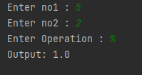

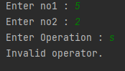

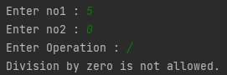

Question 10)

public class q10{  
 public static int *total*;  
 public static void main(String[] args) {  
 int i=0;  
  
 while (i<=100) {  
 *total*=*total*+i;  
 i++;  
 }  
 System.*out*.println("The sum of the first 100 integers is: "+*total*);  
 }  
 }

